Exp Doc No: 58

Employee **Osama Fikry**, SAP Employee ID **58**, Location **UAE**

1. Travel to Europe and makes the following entry

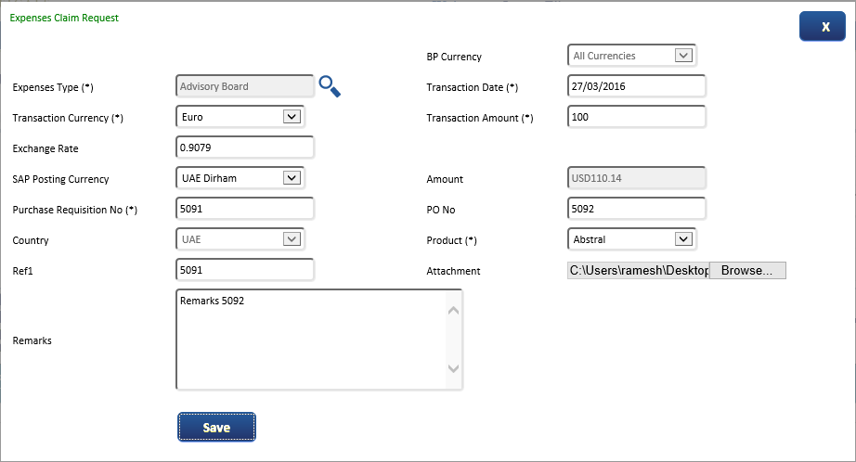

Expected entry for 1 was as below

|  |  |  |  |
| --- | --- | --- | --- |
| Expenses Claim Request |  | BP Currency | All Currency |
| Expense Type |  | Transaction Date |  |
| Transaction Currency | EUR | Transaction Amount | 100 |
| Exchange Rate | 4.14 | (1 EUR = 4.14 AED) |  |
| SAP Posting Currency | AED | Amount | 414 |

2. Travel to Bahrain and makes the following entry

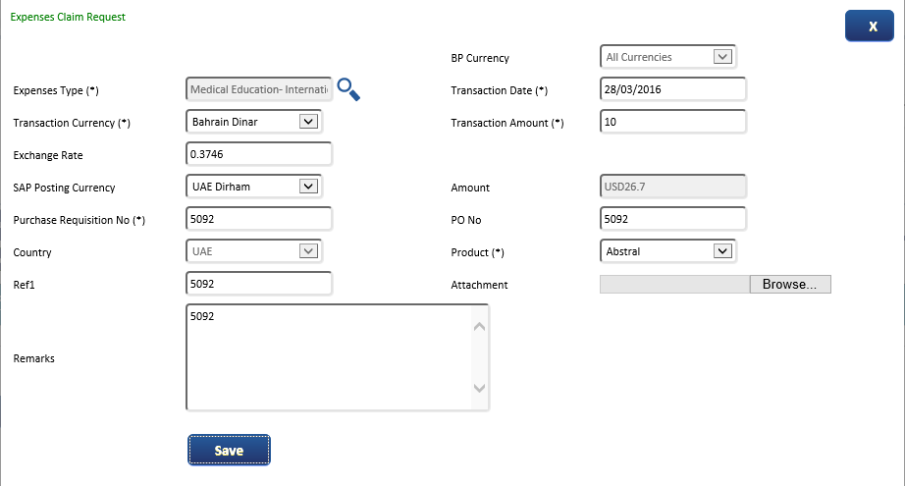

Expected entry for 2 was as below

|  |  |  |  |
| --- | --- | --- | --- |
| Expenses Claim Request |  | BP Currency | All Currency |
| Expense Type |  | Transaction Date |  |
| Transaction Currency | BHD | Transaction Amount | 10 |
| Exchange Rate | 9.74 | (1 BHD = 9.74 AED) |  |
| SAP Posting Currency | AED | Amount | 97.4 |

3. Travel In UAE and makes the following entry

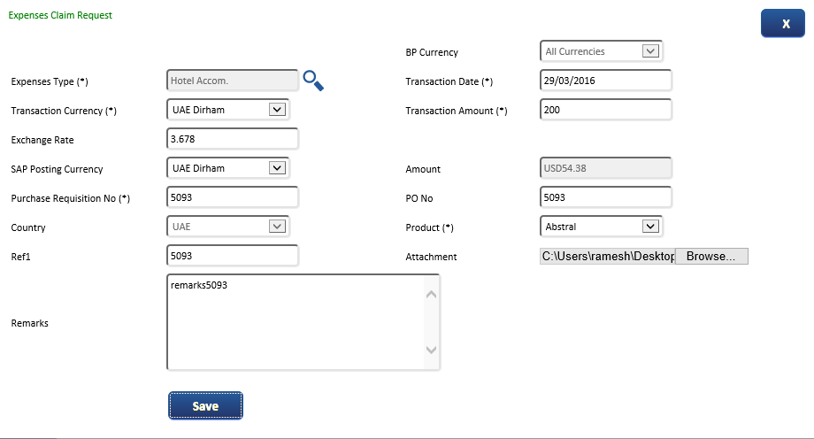

Expected entry for 3 was as below

|  |  |  |  |
| --- | --- | --- | --- |
| Expenses Claim Request |  | BP Currency | All Currency |
| Expense Type |  | Transaction Date |  |
| Transaction Currency | AED | Transaction Amount | 200 |
| Exchange Rate | 1 | (1 AED = 1 AED) |  |
| SAP Posting Currency | AED | Amount | 200 |

Before submission

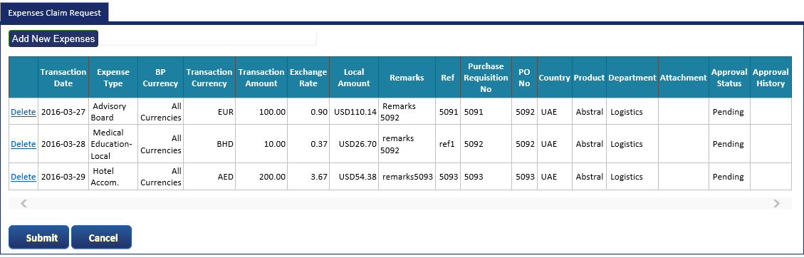

On submission mail to approver

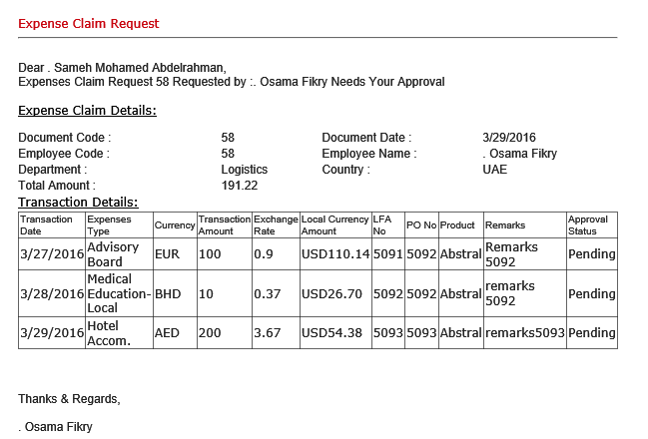

On Approval (Thanks & Regards should of approver)

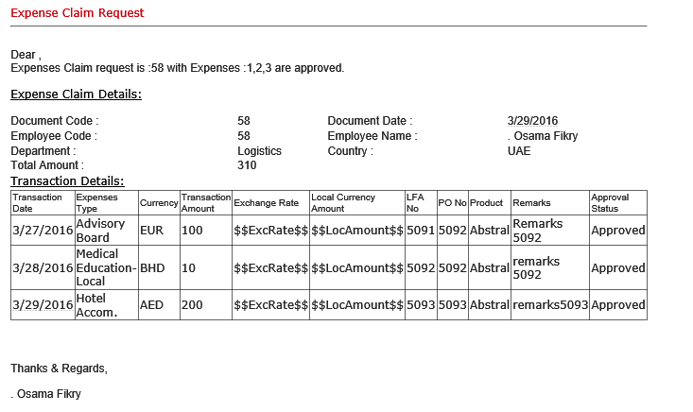

JV posting 1

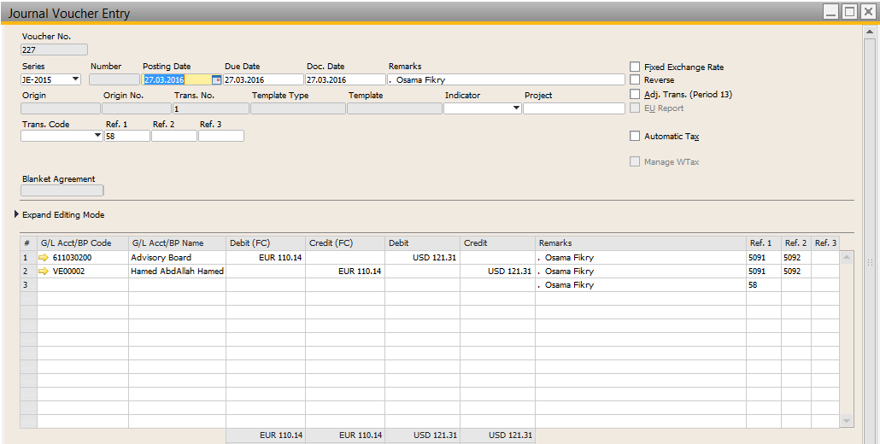

JV posting 2

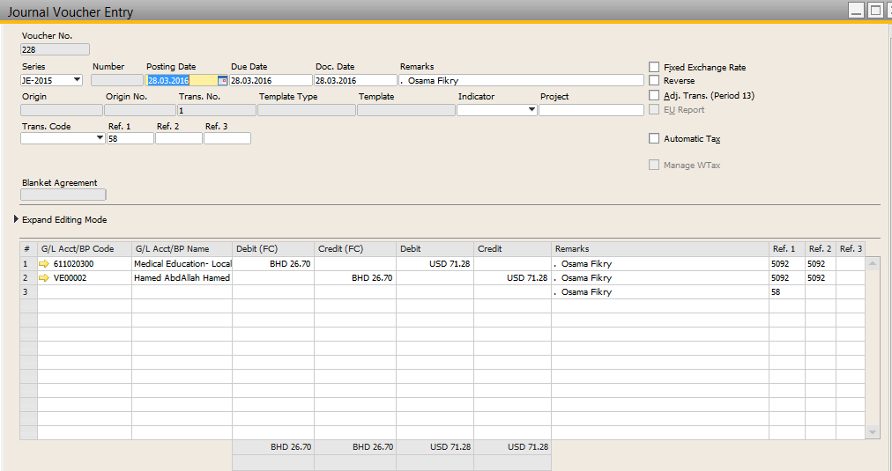

JV posting 3

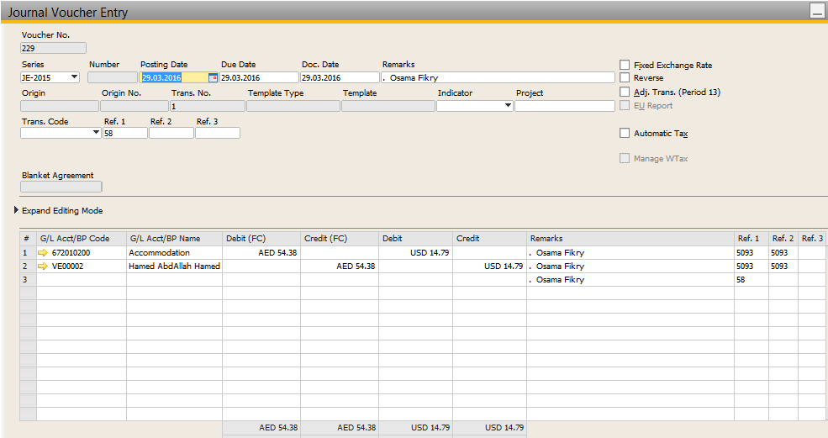

**What should have been the JV posting…. See below**



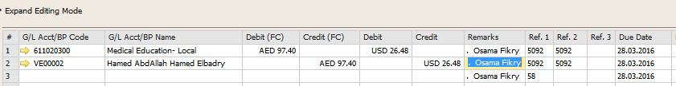

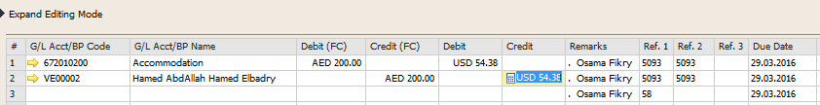

**If we give a direct posting to SAP based on actual expense currency, we will have the below entry**

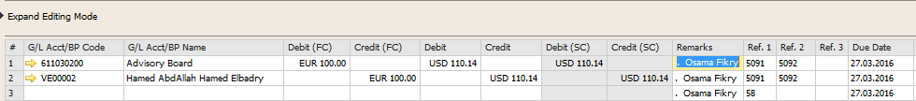

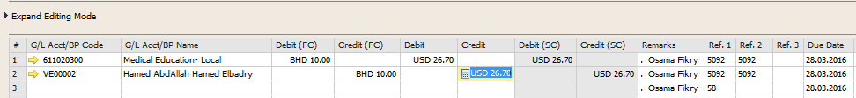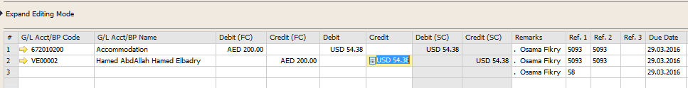

Entry details for Doc 59 and 60 at the end of this document

|  |
| --- |
| TO UNDERSTAND WHY THIS:  The above changes were requested by client for the below reason  >>> An employee located in UAE may travel to different country and incur expense in multiple currency. But the employee is paid at the end of day based on his location (say UAE, so AED).  Due to exchange rate difference there is always a mix up were the employee get paid less or more due to exchange rate difference of multiple currency.  >>> It was very easy for us to ask them to put all the expense based on the employee location currency (though he may make trip to multiple country)  >>> This is fine for employee, but finance was not happy about it. They requested that the actual transaction currency and exchange rate specified by user be also be displayed.  >>> So based on their request we initiated the exchange rate to ESS.  BP Currency: Default currency from BP Master Data  Exchange Rate: Open numeric field for user update (support up to 4 decimals) – In this field user will manually update the exchange rate equal to his location currency (This is for information only)  SAP Posting Currency: Same list display as Transaction Currency – This will be employee location currency  Amount: Transaction Amount * Exchange Rate  >>> This way it is very easy for finance to pay the employee based on his location currency  See example give below ………. |

|  |  |  |  |
| --- | --- | --- | --- |
| Expenses Claim Request |  | BP Currency | All Currency |
| Expense Type |  | Transaction Date |  |
| Transaction Currency | EUR | Transaction Amount | 100 |
| Exchange Rate | 4.14 | (1 EUR = 4.14 AED) |  |
| SAP Posting Currency | AED | Amount | 414 |

SAP posting



|  |  |  |  |
| --- | --- | --- | --- |
| Expenses Claim Request |  | BP Currency | All Currency |
| Expense Type |  | Transaction Date |  |
| Transaction Currency | BHD | Transaction Amount | 10 |
| Exchange Rate | 9.74 | (1 BHD = 9.74 AED) |  |
| SAP Posting Currency | AED | Amount | 97.4 |

SAP posting



|  |  |  |  |
| --- | --- | --- | --- |
| Expenses Claim Request |  | BP Currency | All Currency |
| Expense Type |  | Transaction Date |  |
| Transaction Currency | AED | Transaction Amount | 200 |
| Exchange Rate | 1 | (1 AED = 1 AED) |  |
| SAP Posting Currency | AED | Amount | 200 |

SAP posting



Kindly note below points also:

1. SAP JV has no reference of ESS Document number

2. Kindly keep Department and Country (Dimensions) also open for user to change if required. i.e. display as default from employee master data, but let user be able to change in ESS )

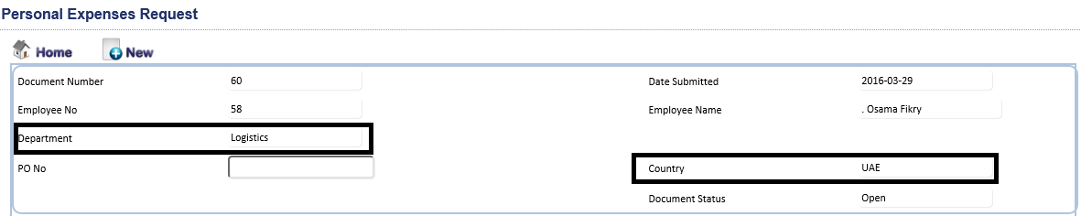

3. Attachment file size : Display a text to indicate maximum size for attachment as 400 KB only

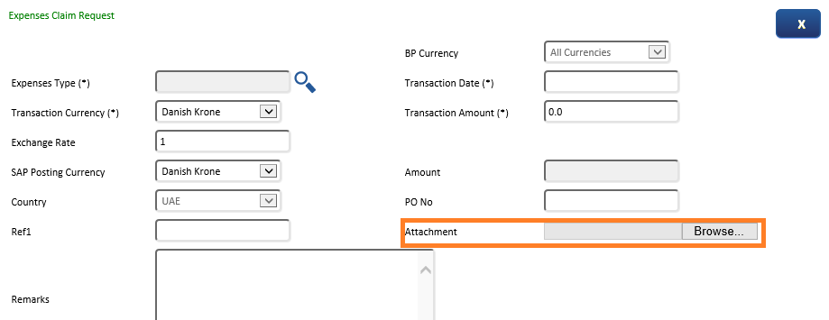

---------------------------------------------------------------------------

Below details is for information only

Exp Doc No: 59

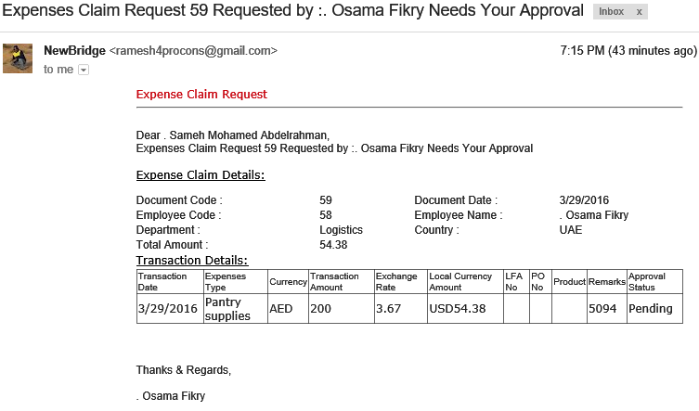

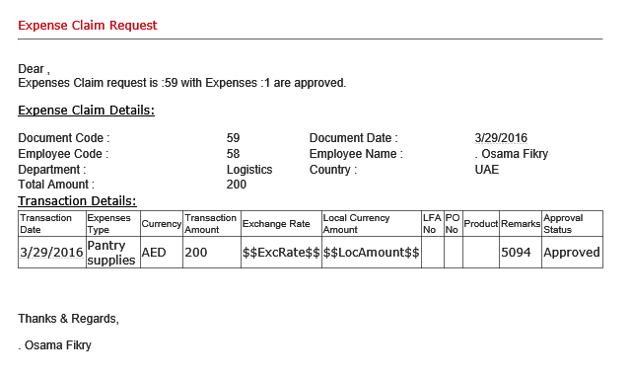

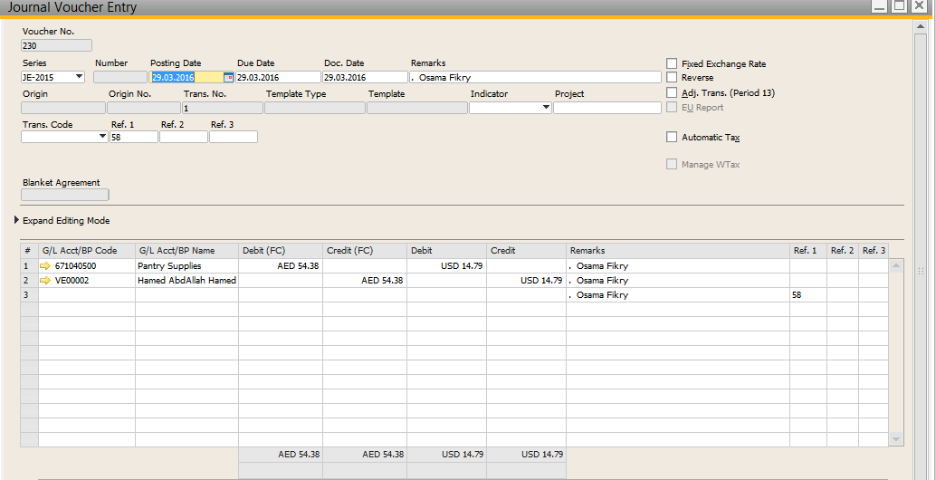

Exp Doc No: 60

